2.4 GHZ IEEE 802.15.4/ ZIGBEE RF TRANSCEIVER

ORIGIN OF NAME ZIGBEE

The domestic honeybee, a colonial insect, lives in a hive that contains a queen, a few male drones, and thousands of worker bees. The survival, success, and future of the colony is dependent upon continuous communication of vital information between every member of the colony.
The technique that honey bees use to communicate new-found food sources to other members of the colony is referred to as the ZigBee Principle. Using this silent, but powerful communication system, whereby the bee dances in a zig-zag pattern, she is able to share information such as the location, distance, and direction of a newly discovered food source to her fellow colony members. Instinctively implementing the ZigBee Principle, bees around the world industriously sustain productive hives and foster future generations of colony members.

What is ZigBee
- ZigBee is a Ad-hoc networking technology for LR-WPAN
- Based On IEEE 802.15.4 standard that defines the PHY and Mac Layers for ZigBee.
- Intended for 2.45 Ghz , 868 Mhz and 915 Mhz Band.
- Low in cost ,complexity & power consumption as compared to competing technologies.
- Intended to network inexpensive devices
- Data rates touch 250Kbps for 2.45Ghz ,40 Kbps 915Mhz and 20Kbps for 868Mhz band.
DESCRIPTION

The CC2520 is TI's second generation ZigBee / IEEE 802.15.4 RF transceiver for the 2.4 GHz unlicensed ISM band. This chip enables industrial grade applications by offering state-of-the-art selectivity/co-existence, excellent link budget, operation up to 125°C and low voltage operation. In addition, the CC2520 provides extensive hardware support for frame handling, data buffering, burst transmissions, data encryption, data authentication, clear channel assessment, link quality indication and frame timing information. These features reduce the load on the host controller. In a typical system, the CC2520 will be used together with a microcontroller and a few additional passive components.

KEY FEATURES
Location Engine calculates the location of a node in a network
• High performance and low power 8051 microcontroller core.
• 2.4 GHz IEEE 802.15.4 compliant RF transceiver (industry leading CC2420 radio core).
• ZigBee® protocol stack (Z-Stack™) from Texas Instruments includes support for CC2431 ‘s location engine.
• Excellent receiver sensitivity and robustness tointerferers
• 128 KB in-system programmable flash
• 8 KB RAM, 4 KB with data retention in all power modes
• Powerful DMA functionality
• Very few external components
• Only a single crystal needed for mesh network systems
• Low current consumption (RX: 27 mA, TX: 27 mA, microcontroller running at 32 MHz)
• Only 0.5µA current consumption in powerdown mode, where external interrupts or the RTC can wake up the system
• 0.3 µA current consumption in power-down mode, where external interrupts can wake up the system
• Very fast transition times from low-power modes to active mode enables ultra low average power consumption in low duty-cycle systems
• CSMA/CA hardware support
• Wide supply voltage range (2.0 V – 3.6 V)
• Digital RSSI/ LQI support
• Battery monitor and temperature sensor
• ADC with up to eight inputs and configurable resolution
• 128-bit AES security coprocessor
•Two powerful USARTs with support for several serial protocols.
• Hardware debug support
• Watchdog timer
• One IEEE 802.15.4 MAC Timer, one general 16-bit timer and two 8-bit timers
• RoHS compliant 7x7 mm QLP48 package
• 21 general I/O pins, two with 20 mA sink/source capability
• Powerful and flexible development tools Available
Low Power
• RX (receiving frame, -50 dBm) 18.5 mA
• TX 33.6 mA @ +5 dBm
• TX 25.8 mA @ 0 dBm
• <1µA in power down
• Digital RSSI/LQI support
• Automatic clear channel assessment for
CSMA/CA
• Automatic CRC
• 768 bytes RAM for flexible buffering and security processing
• Fully supported MAC security
• 4 wire SPI
• 6 configurable IO pins
• Interrupt generator
• Frame filtering and processing engine
• Random number generator
Development Tools
• Reference design
• IEEE 802.15.4 MAC software
• ZigBee® stack software
• Fully equipped development kit
• Packet sniffer support in hardware

IEEE 802.15.4 MAC Hardware Support

• Automatic preamble generator
• Synchronization word insertion and detection
• CRC-16 computation and verification over the MAC payload
• Frame filtering
• Automatic ACK and setting of the pending-bit
• Clear Channel Assessment (CCA)
• Energy detection / RSSI
• Link Quality Indication (LQI)
• Fully automatic MAC security (CTR, CBC-MAC, CCM)
IEEE 802.15.4 Device Definitions

COMPARISON :
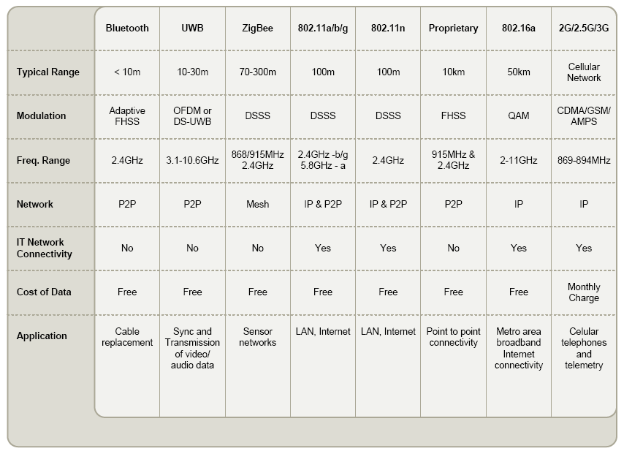
BLUETOOTH ZIGBEE COMPARISON OF PAN NETWORKS
- ZigBee Protocol was developed to serve very different applications than Bluetooth and leads to tremendous optimizations in power consumption. Some of the key protocol differentiators are:
- ZigBee:
  - Very low duty cycle, very long primary battery life,
  - Static and dynamic star and mesh networks, >65,000 nodes, with low latency available,
  - Ability to remain quiescent for long periods without communications,
  - Direct Sequence Spread Spectrum allows devices to sleep without the requirement for close synchronization.
- Bluetooth:
  - Moderate duty cycle, secondary battery lasts same as master,
  - Very high QoS and very low, guaranteed latency,
  - Quasi-static star network up to seven clients with ability to participate in more than one network,
  - Frequency Hopping Spread Spectrum is extremely difficult to create extended networks without large synchronization cost.

DISTANCE ANALYSIS MAPING:
  - 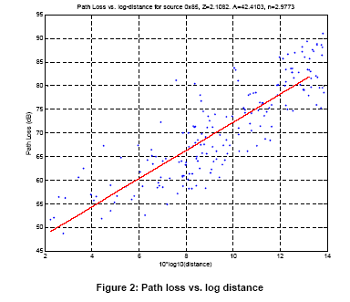
ZIGBEE LAYERS
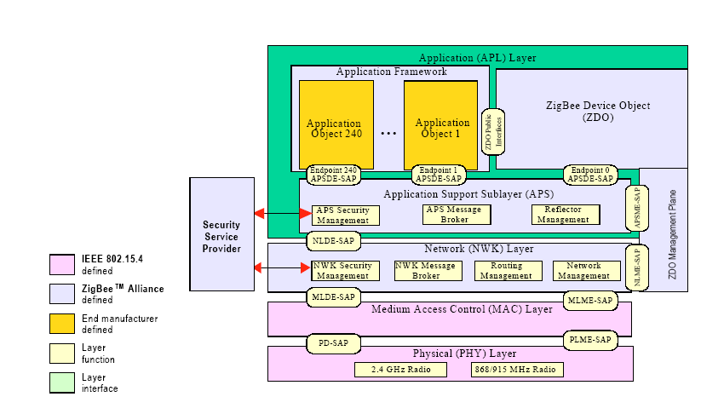

ZIGBEENETWORKDEVICES
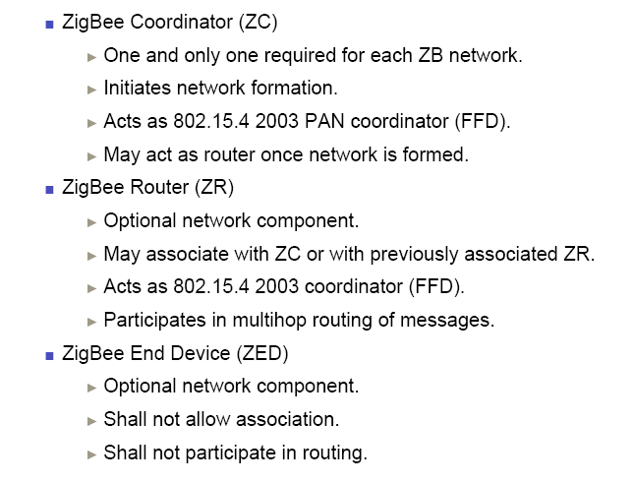

TYPICAL IMPLEMENTATION’S
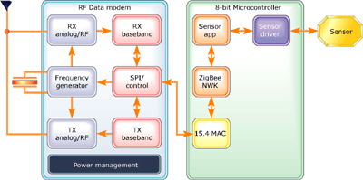
NETWORK ARCHITECTURE
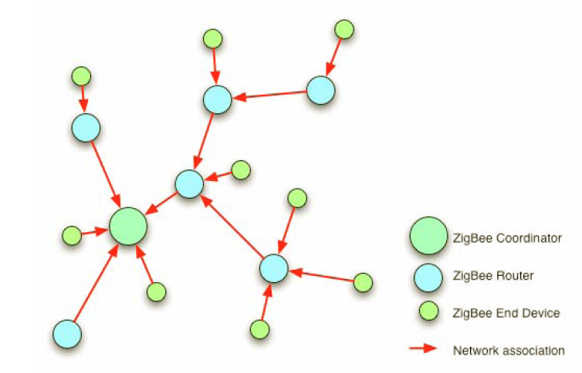
APPLICATION SECTORS

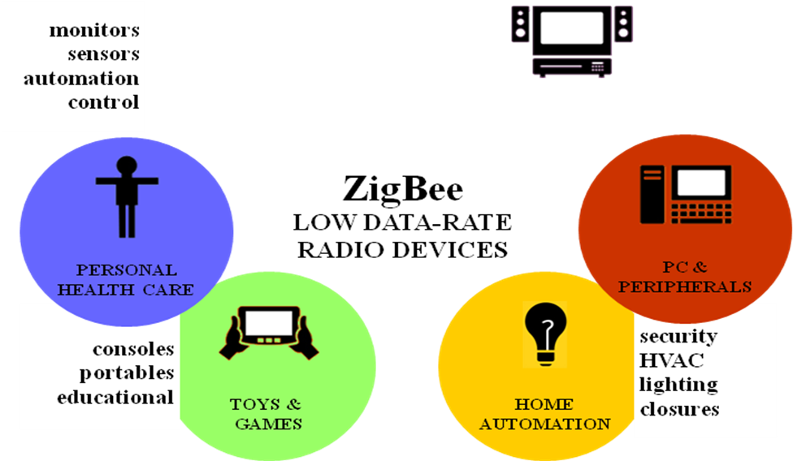

Applications
• ZigBee systems
• 2.4 GHz IEEE 802.15.4 systems
• Home/building automation
• Industrial Control and Monitoring
• Low power wireless sensor networks
• Access Control
• PC peripherals
• Set-top boxes and remote controls
• Consumer Electronics
• Container/Vehicle Tracking
• Active RFID
• Inventory Control

